Отчет по практической работе № 8

Тема: Разработать программный модуль для вывода данных в MS Excel:

1. вывести данные, создавая программно новый файл .xlsx
2. вывести данные в шаблон (например, файл Шаблон.xlsx)

Выполнил: студент гр. ИСП.21.1А Жигач Дмитрий

Вариант № 9. Предметная область: Сельскохозяйственные работы.

Ход работы:

1. Подключил ссылку на Microsoft.Office.Interop.Excel

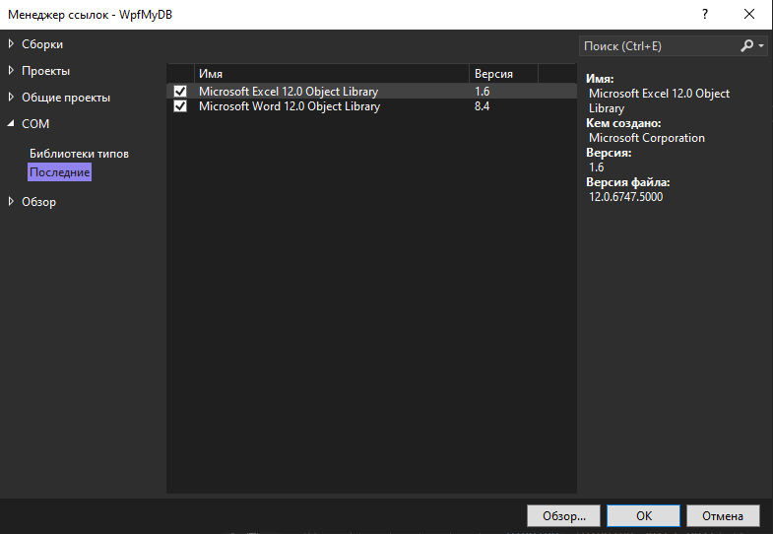

1. Добавил 2 кнопки: Импорт в Excel и Импорт в шаблон Excel:

<DockPanel>

<Button

Content="Excel"

HorizontalAlignment="Left"

VerticalAlignment="Bottom"

Width="100"

Background="#FFCBAAFF" Foreground="White" FontFamily="Arial Black"

Click="ExcelButton_Click" Height="50"

Margin="10"/>

<Button

Content="Excel шаблон"

HorizontalAlignment="Left"

VerticalAlignment="Bottom"

Width="100"

Background="#FFCBAAFF" Foreground="White" FontFamily="Arial Black"

Click="ExcelButton2_Click" Height="50"

Margin="10"/>

</DockPanel> 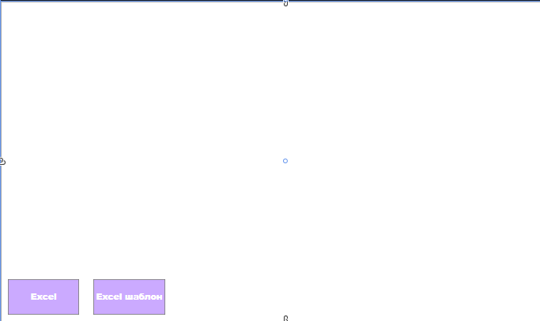

1. Подключил Excel в pr9.cs:

using Excel = Microsoft.Office.Interop.Excel;

Добавил определение к кнопке BtnExcel:

private void ExcelButton_Click(object sender, RoutedEventArgs e)

{

var app = new Excel.Application();

Excel.Workbook workbook = app.Workbooks.Add();

Excel.Worksheet worksheet = (Excel.Worksheet)workbook.Worksheets[1];

int indexRows = 1;

worksheet.Cells[1, indexRows] = "id";

worksheet.Cells[2, indexRows] = "company_name";

worksheet.Cells[3, indexRows] = "product_name";

worksheet.Cells[4, indexRows] = "unit_of_measurement";

worksheet.Cells[5, indexRows] = "purchase_price";

worksheet.Cells[6, indexRows] = "delivery_date";

worksheet.Cells[7, indexRows] = "volume";

worksheet.Cells[8, indexRows] = "cost";

using (var context = new YourDataContext())

{

var listProducts = context.products.ToList();

foreach (var item in listProducts)

{

indexRows++;

worksheet.Cells[1, indexRows] = indexRows - 1;

worksheet.Cells[2, indexRows] = item.company_name;

worksheet.Cells[3, indexRows] = item.product_name;

worksheet.Cells[4, indexRows] = item.unit_of_measurement;

worksheet.Cells[5, indexRows] = item.purchase_price;

worksheet.Cells[6, indexRows] = item.delivery_date;

worksheet.Cells[7, indexRows] = item.volume;

worksheet.Cells[8, indexRows] = item.cost;

}

}

app.Visible = true;

}

1. Добавил определение к кнопке BtnExcel2:

private void ExcelButton2_Click(object sender, RoutedEventArgs e)

{

var app = new Excel.Application();

Excel.Workbook workbook = app.Workbooks.Add();

Excel.Worksheet worksheet (Excel.Worksheet)workbook.Worksheets[1];

int indexRows = 1;

worksheet.Cells[1, indexRows] = "id";

worksheet.Cells[2, indexRows] = "company_name";

worksheet.Cells[3, indexRows] = "product_name";

worksheet.Cells[4, indexRows] = "unit_of_measurement";

worksheet.Cells[5, indexRows] = "purchase_price";

worksheet.Cells[6, indexRows] = "delivery_date";

worksheet.Cells[7, indexRows] = "volume";

worksheet.Cells[8, indexRows] = "cost";

List<products> listProducts;

using (var context = new YourDataContext())

{

listProducts = context.products.ToList();

foreach (var item in listProducts)

{

indexRows++;

worksheet.Cells[1, indexRows] = indexRows - 1;

worksheet.Cells[2, indexRows] = item.company_name;

worksheet.Cells[3, indexRows] = item.product_name;

worksheet.Cells[4, indexRows] = item.unit_of_measurement;

worksheet.Cells[5, indexRows] = item.purchase_price;

worksheet.Cells[6, indexRows] = item.delivery_date;

worksheet.Cells[7, indexRows] = item.volume;

worksheet.Cells[8, indexRows] = item.cost;

}

}

Excel.Range sumRange = worksheet.Range[worksheet.Cells[1][indexRows + 1], worksheet.Cells[2][indexRows + 1]];

sumRange.Merge();

sumRange.Value = "Итого:";

sumRange.HorizontalAlignment = Excel.XlHAlign.xlHAlignRight;

worksheet.Cells[3][indexRows + 1].Formula = $"=SUM(C{indexRows + 1 - listProducts.Count()}:" + $"C{indexRows})";

app.Visible = true;

}

Результат:

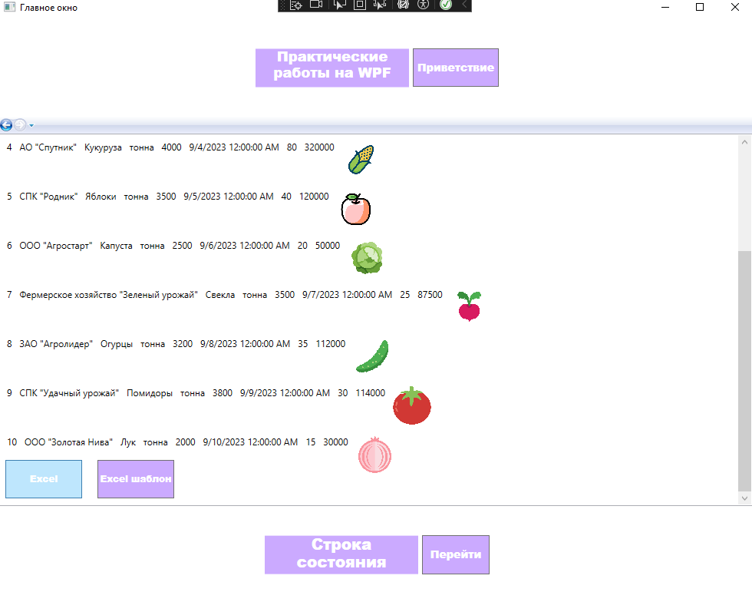

Рис.1 Нажимаем на кнопку «Excel»

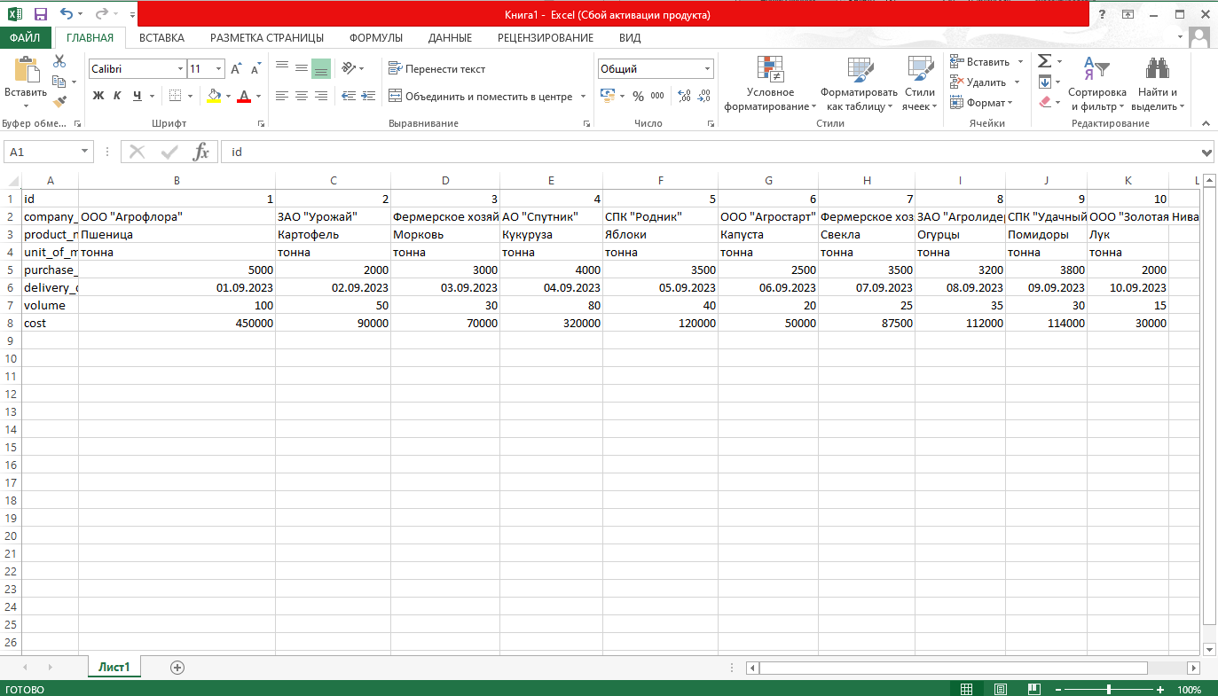

Рис.2 Создается и открывается файл Excel с таблицей

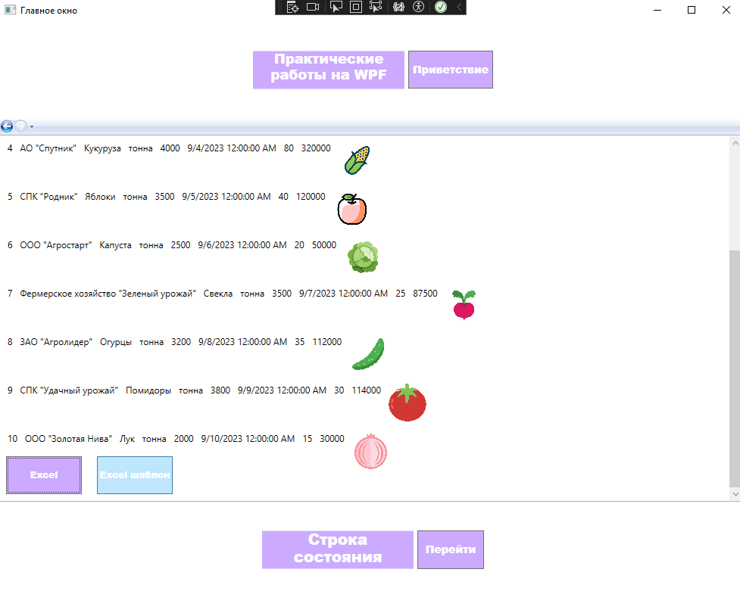

Рис.3 Нажимаем кнопку «Импорт в шаблон Excel»

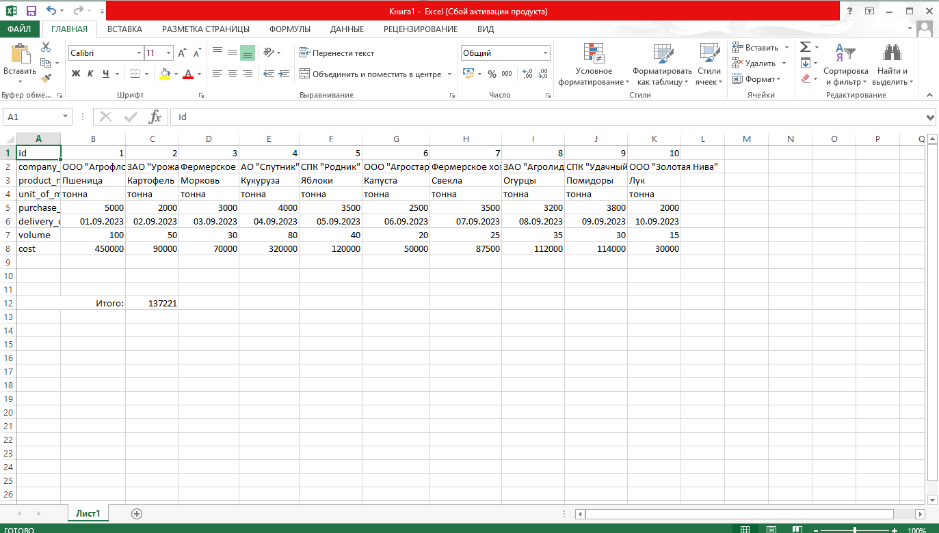

Рис.4 Открывается файл шаблона с добавленной формулой суммы всех значений по полю «cost»